4/26/2023

Admin

Umair Rasheed

GMCa 6

Assignment Week 5

Working with Excel and Tableau

Table of Contents

Table of Contents1

Data and Data Structures2

Development of Data sets using Excel3

Policies and procedures while working with Data4

Set a password to protect the workbook 5

change the data to display in British Pound7

Turn the GDP sheet into a table……………………………………………………………………………….8

Filter the table to display only the information for 2019……………………………………………………..9

Create a chart that will only display the following data…………………………………………………….12

Create a sort for the top 20 highest ranking counties………………………………………………………15

Create a new Bar chart to display the 20 highest ranking countries……………………………………..17

Summary and assignment evaluation…………………………………………………………………………………18

Print, Save and Copy Macro Button…………………………………………………………………………………….19

Tableau………………………………………………………………………………………………………………………………28

Final Dashboard / Link to Tableau Public….…………………………………………………………………………31

Introduction to Data and Data Structures:

## Data refers to any kind of information that can be stored, processed, and communicated by a computer. This includes everything from text, numbers, images, and audio to more complex structures like databases, graphs, and networks.

## In order to organize and manipulate data efficiently, computer scientists and programmers have developed various data structures. Data structures are specialized formats for organizing and storing data in memory, which allow for fast and efficient access and manipulation of data.

Data Structures:

## Some common data structures include:

## Arrays: a collection of items stored in contiguous memory locations, accessed using an index.

## Linked lists: a sequence of nodes, each containing a data element and a pointer to the next node in the sequence.

## Stacks: a last-in-first-out (LIFO) data structure, where items are added and removed from the same end.

## Queues: a first-in-first-out (FIFO) data structure, where items are added to one end and removed from the other.

## Trees: a hierarchical data structure where each node has a parent and zero or more children.

## Graphs: a collection of vertices and edges that connect them, allowing for complex relationships to be represented.

## Choosing the appropriate data structure is an important part of designing efficient algorithms and software. Understanding the characteristics and trade-offs of different data structures can help developers build more performant and scalable systems.

Development of Data sets using Excel:

## Excel is a popular tool for managing and analyzing data, and it offers many features to help users create and manipulate data sets.

## The development of a data set in Excel typically involves organizing data into columns and rows, and applying formatting and formulas as needed. Users can import data from other sources, such as text files or databases, or manually enter data directly into Excel. Once the data is in Excel, users can use various functions and tools to sort, filter, and analyze the data. Pivot tables are a powerful feature of Excel that allow users to summarize and analyze large data sets in a visual and interactive way.

## Additionally, Excel offers many charting options to help users visualize trends and patterns in their data. Overall, Excel provides a user-friendly interface and many powerful features for developing and analyzing data sets.

Policies and Procedure while working with Data:

## When working with data, there are several policies that need to be adhered to in order to ensure the proper handling and protection of sensitive information. Here are some examples of policies that should be considered:

## Data Privacy: Data privacy policies ensure that personal or confidential data is collected, processed, and stored in a manner that is consistent with the regulations and laws of the jurisdiction in which the data resides.

## Data Security: Data security policies define the measures taken to protect data from unauthorized access, modification, or destruction. This includes physical, technical, and administrative safeguards.

## Data Retention: Data retention policies define how long data should be kept, and when it should be destroyed. This is important for complying with legal or regulatory requirements, as well as for managing storage resources.

## Data Access: Data access policies define who has access to data, under what conditions, and for what purposes. This includes policies for sharing data within an organization or with external parties.

## Data Quality: Data quality policies define the standards for data accuracy, completeness, consistency, and timeliness. These policies ensure that data is fit for its intended purpose and can be relied upon for decision-making.

Set a password to protect the workbook

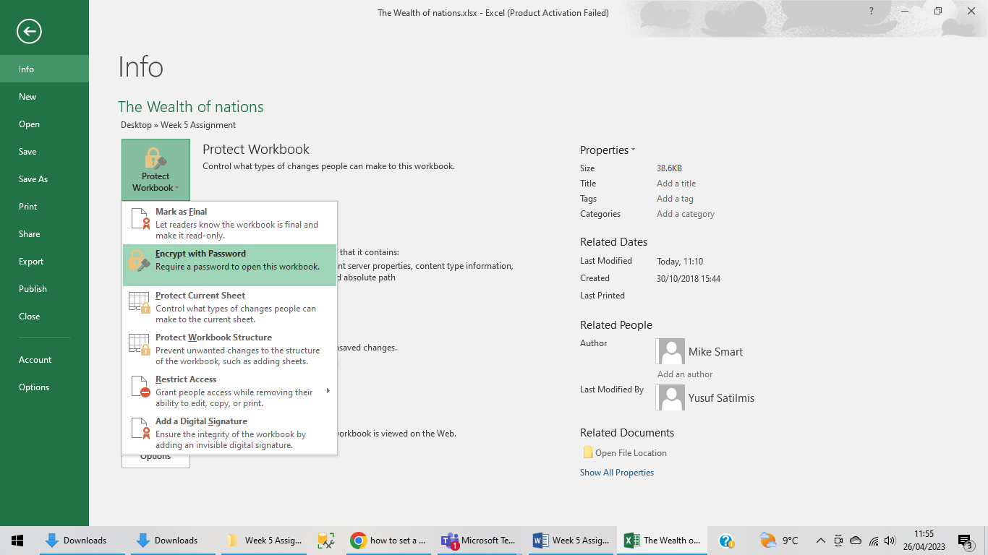

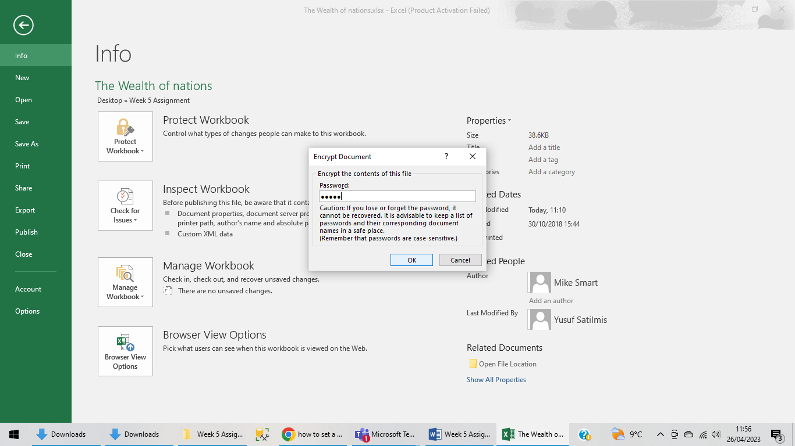

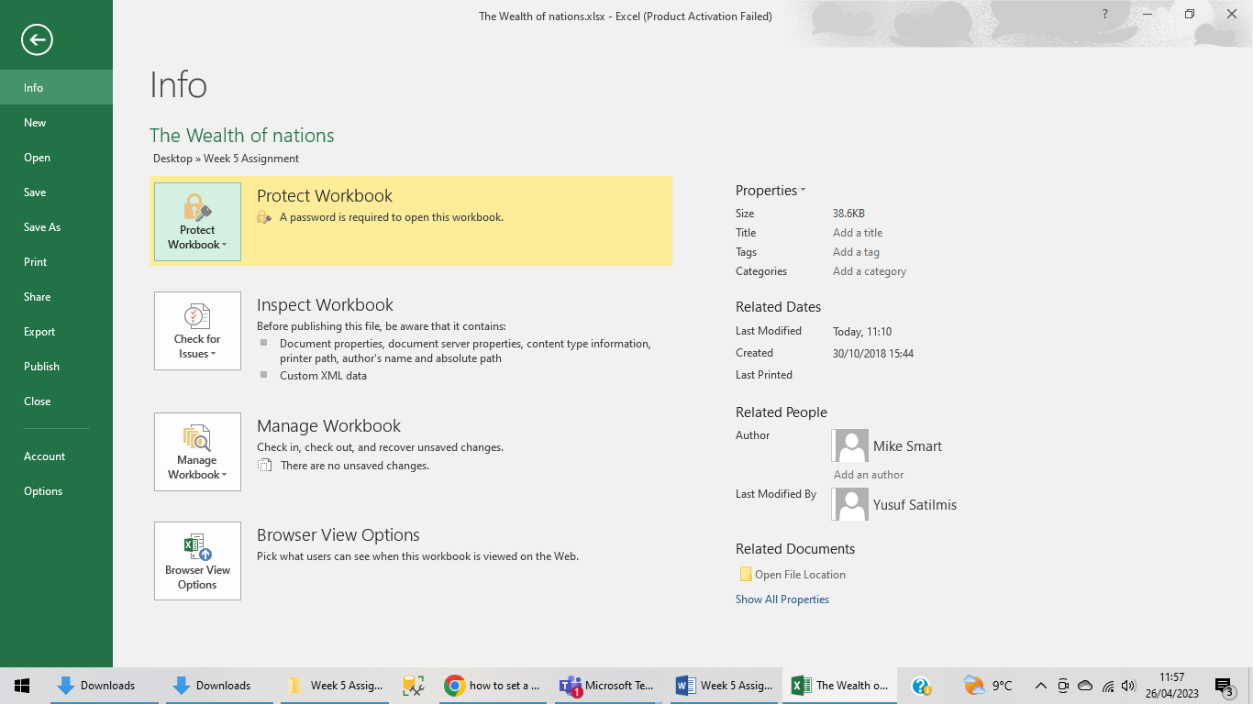

Highlight column C and change the data to display in British Pound symbol

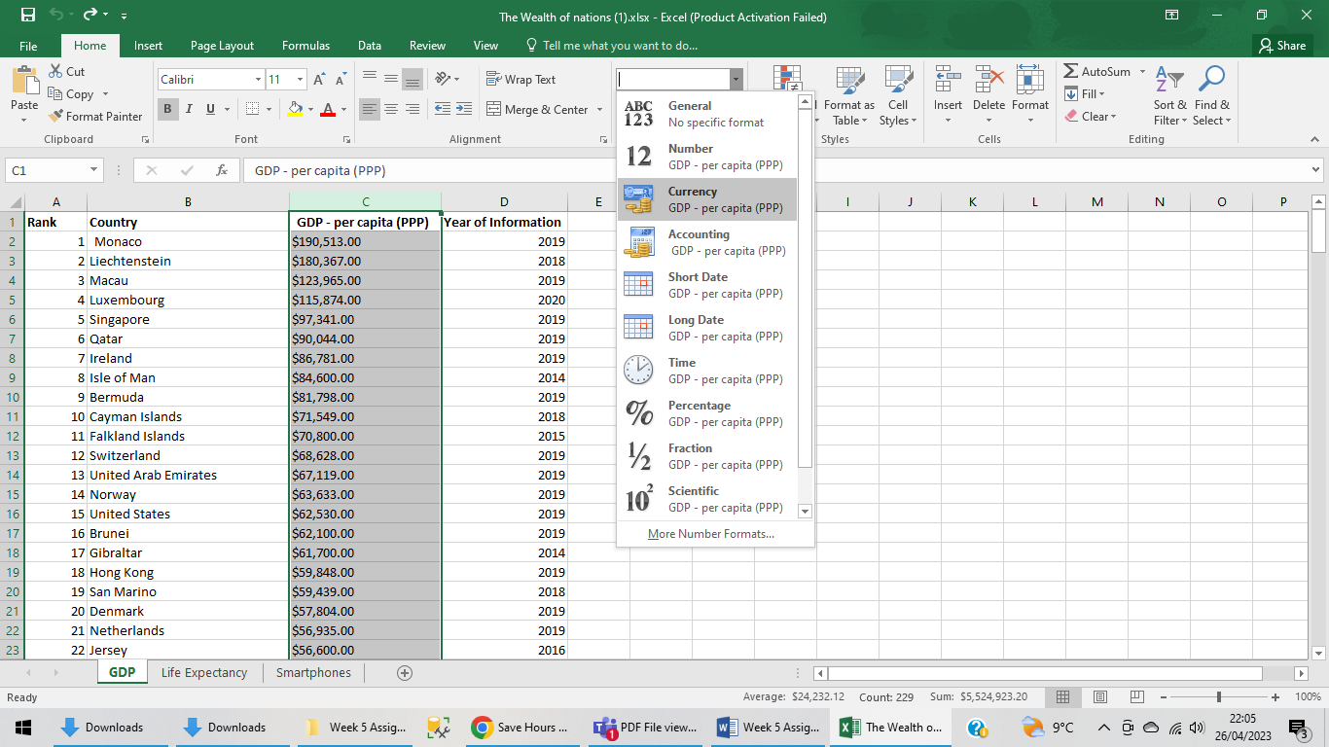

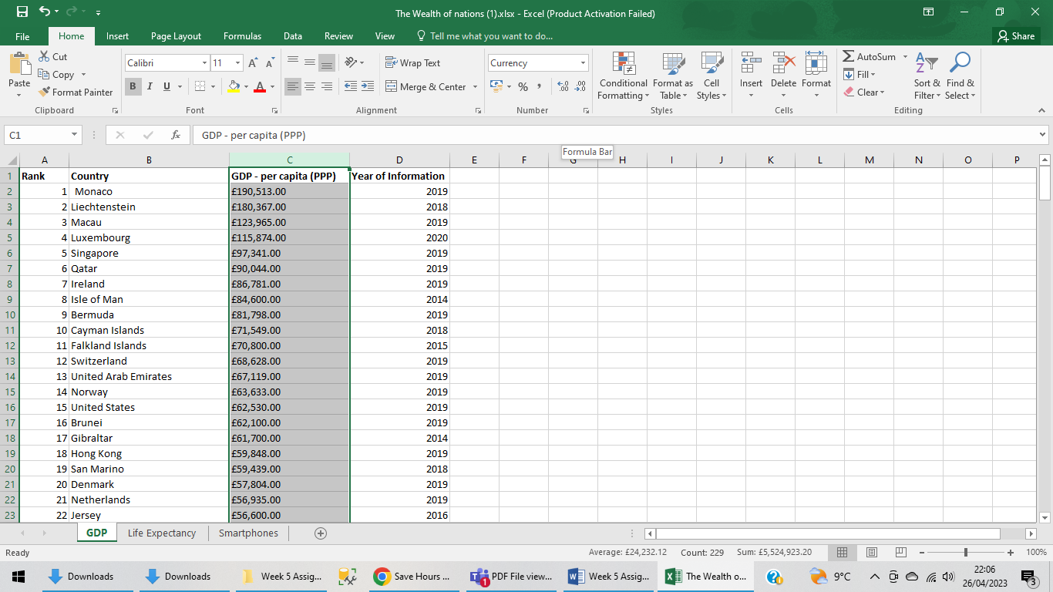

Turn the GDP sheet into a table.

Highlight anywhere in the cells and select CTRL T

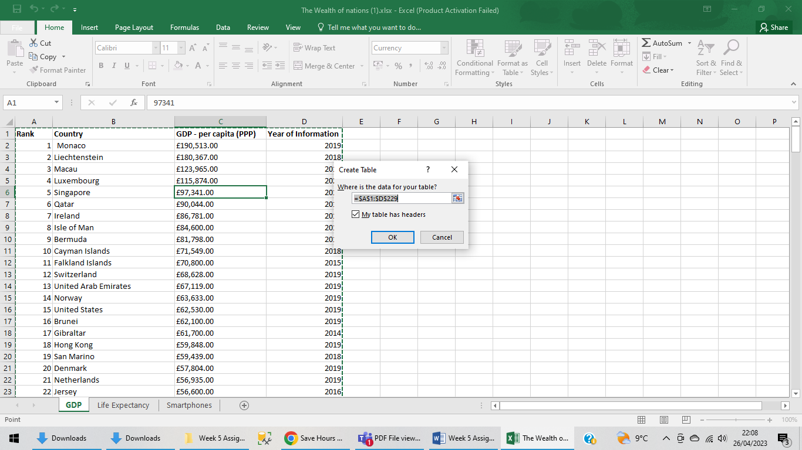

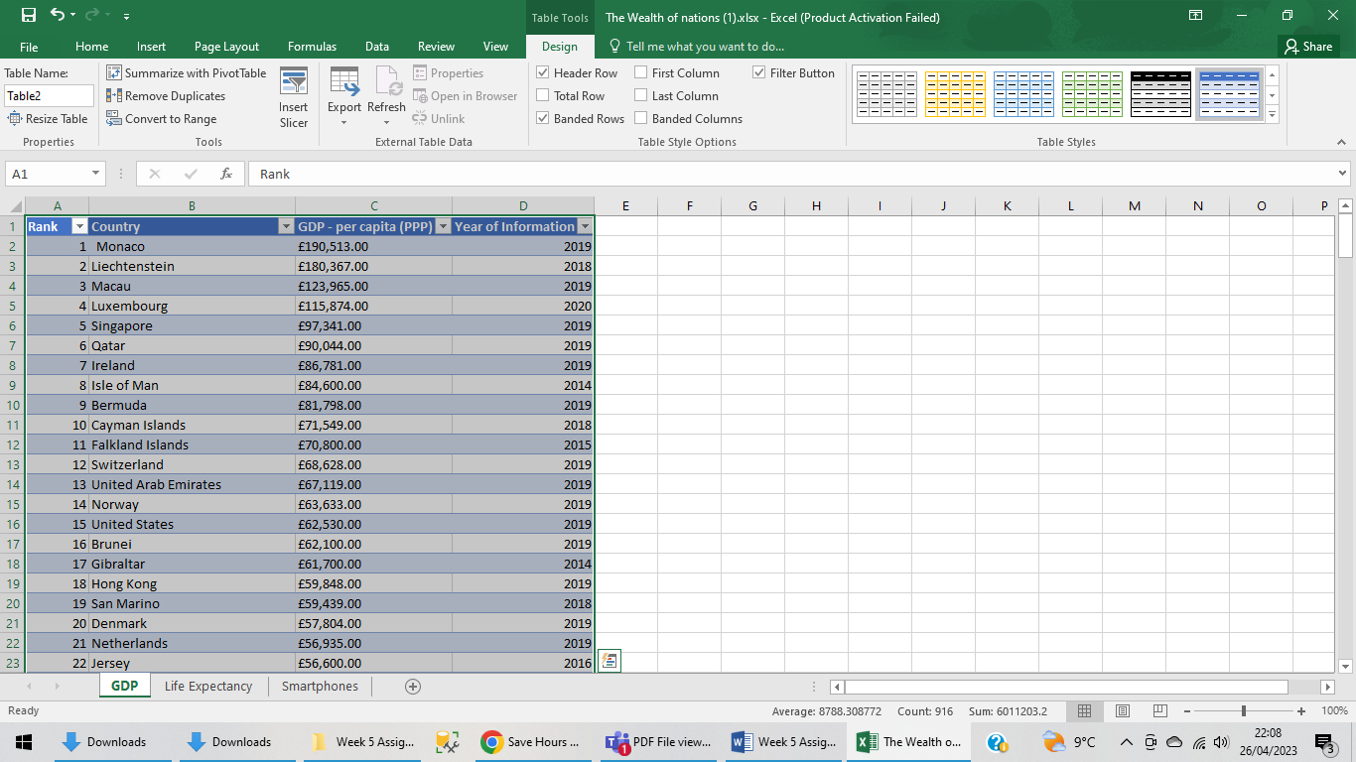

Filter the table to display only the information for 2019

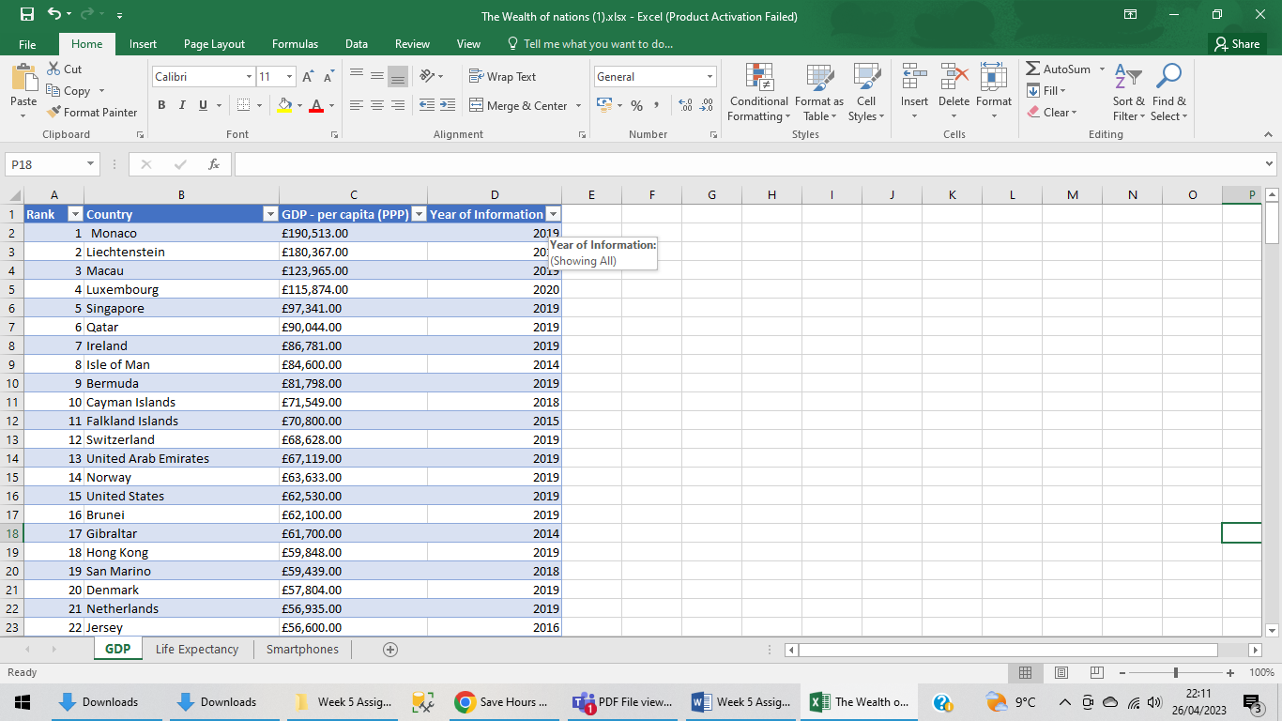

Uncheck select all

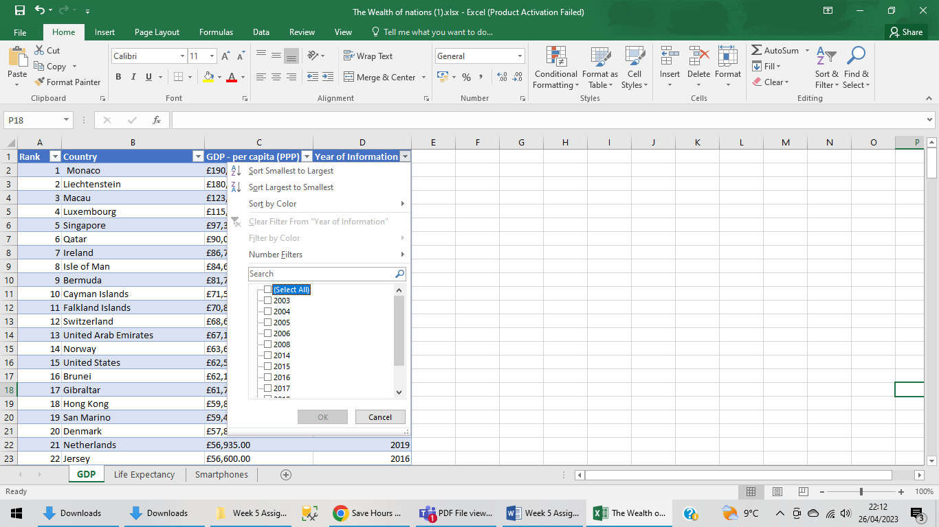

Check 2019 and press OK

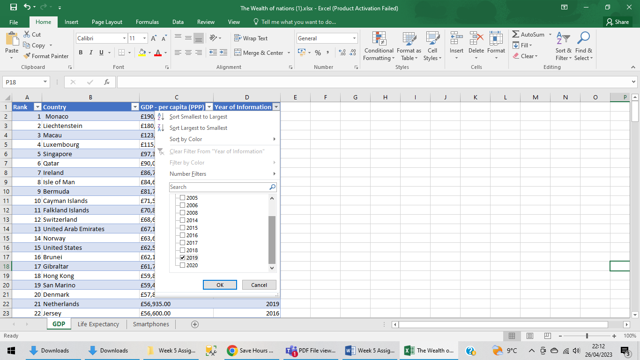

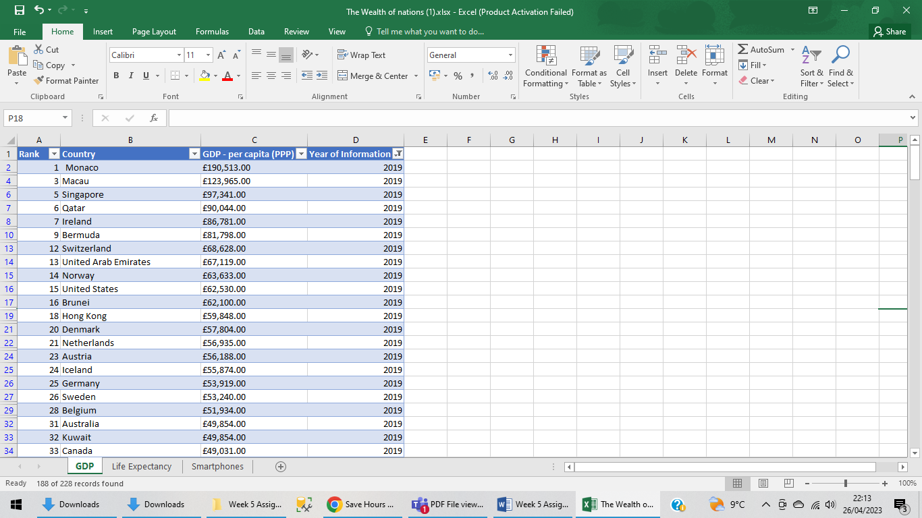

Next create a chart that will only display the following data ‘Rank, Country and GDP -per capita (PPP). The chart can be anything as long as it is suitable.

Highlight the 3 columns by pressing CTRL

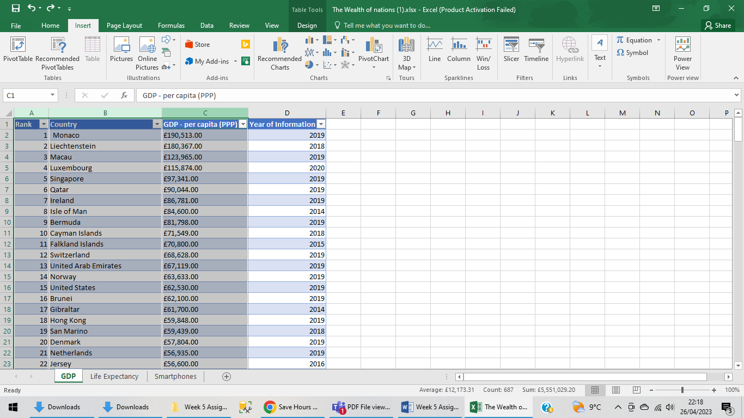

Go to insert and choose your chart

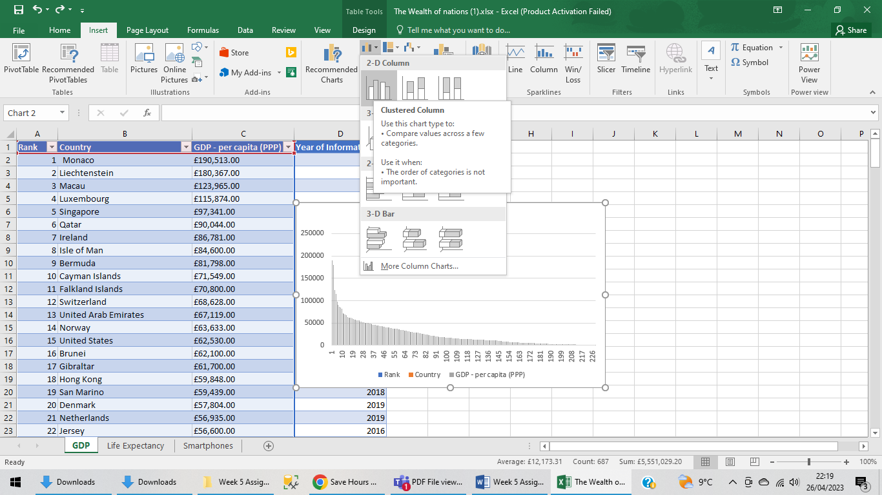

Using your creative skills edit the chart

a .Add a title

b. Add X and Y axis labels

c.Make the chart visually pleasing

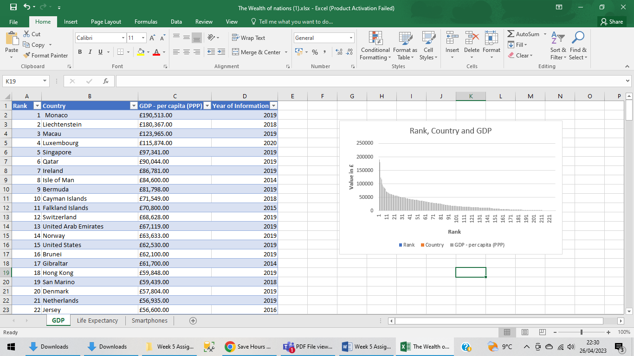

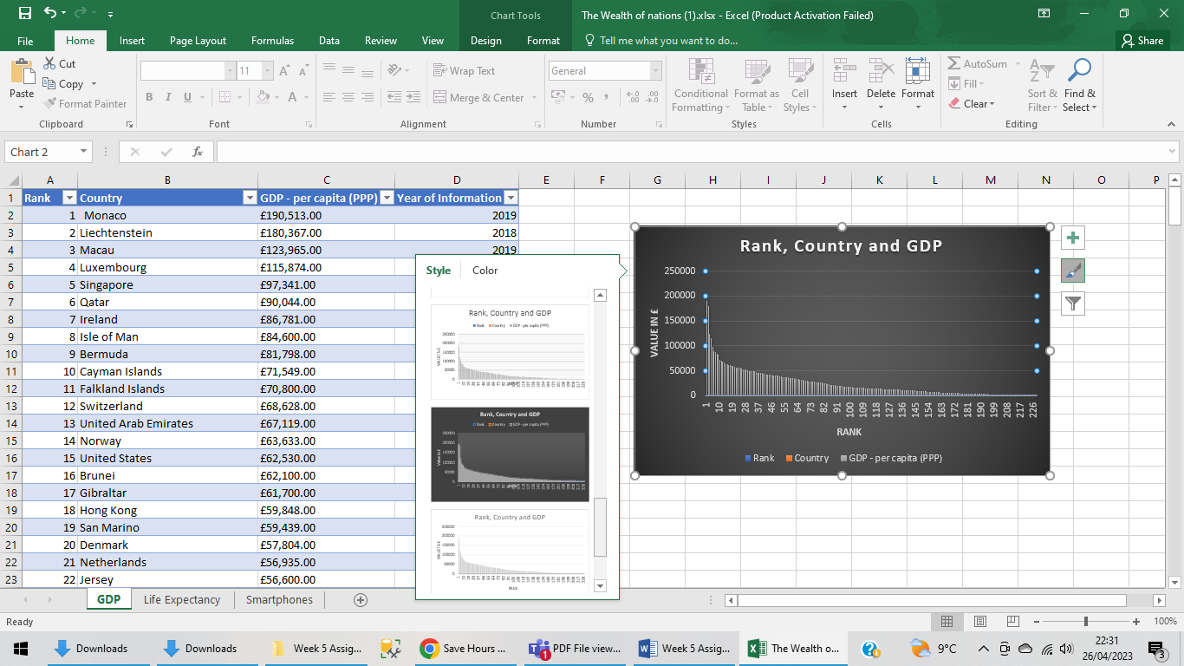

Move the chart to a new sheet tab and label with a suitable name

CTRL X and add a sheet from the bottom and CTRL V

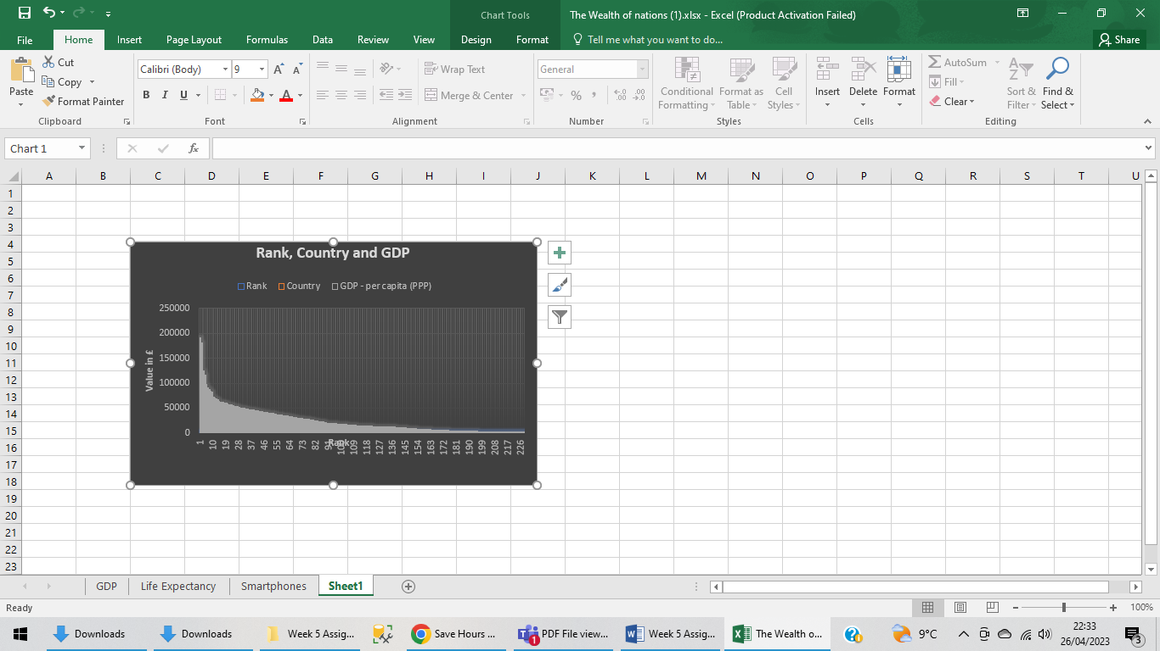

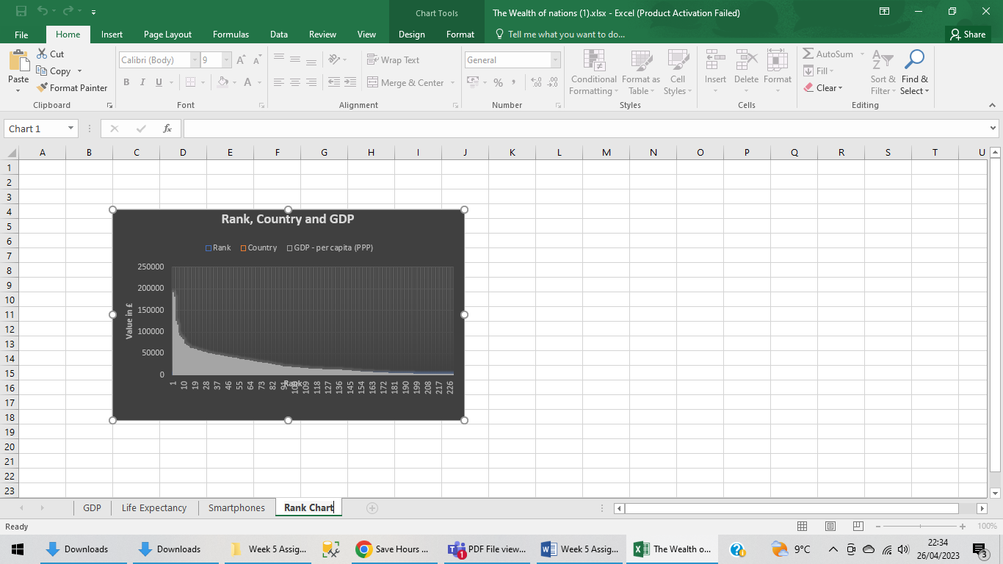

Create a sort for the top 20 highest ranking counties

Go to filters, numbers and then choose Less then or equal to and put 20 there.

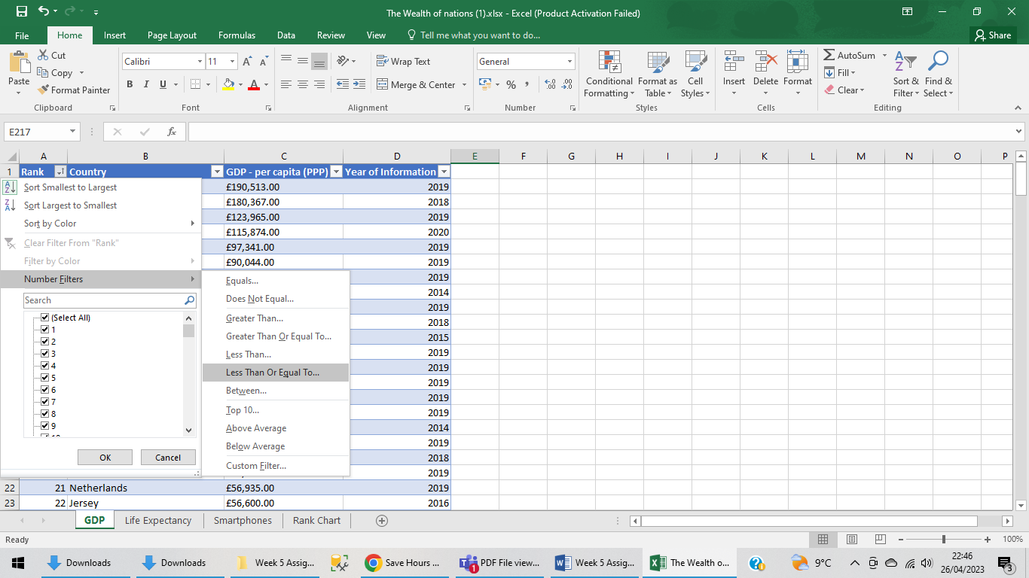

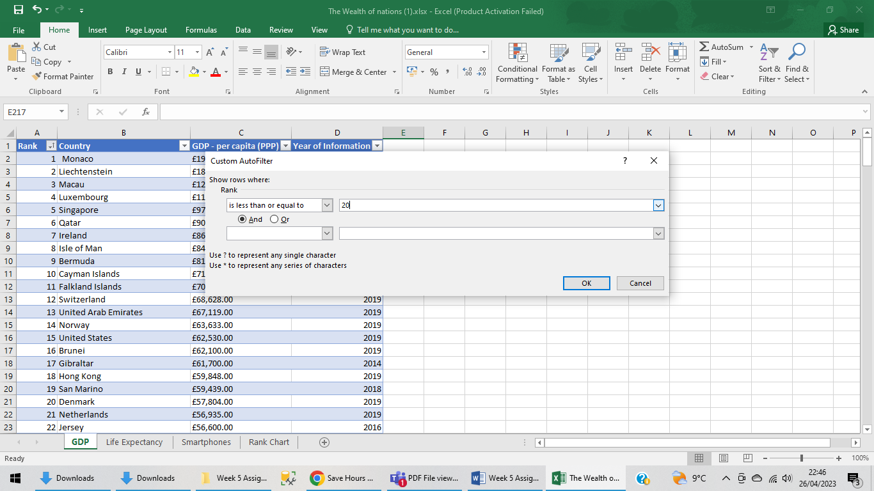

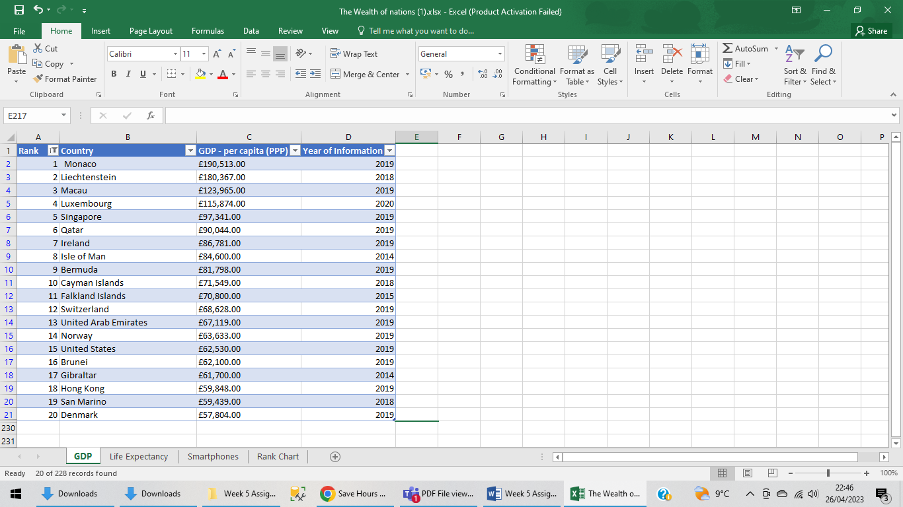

Next create a new Bar chart to display the 20 highest ranking countries from your sort and then move the chart to be underneath the table, as shown below

Colour the background by highlighting the area underneath the table as shown below. Find then add a fill colour icon and select a colour.

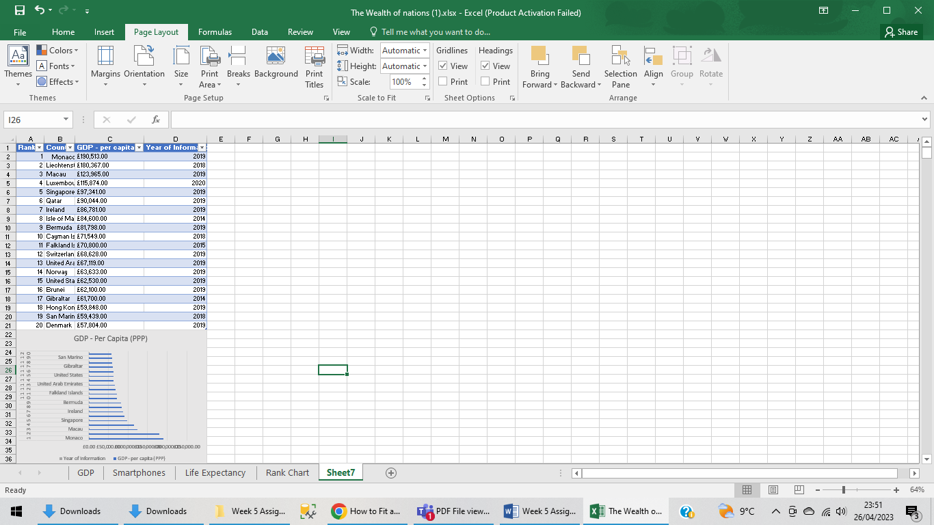

**Summary and assignment evaluation:**

I need to work more on tips and tricks in Excel as there are always more than one way to perform an action and the quickest is the most helpful. Although there is always help available over the internet, finding the right solution could be difficult at times so the best way is to keep practicing so that there would be less need to go online and search.

It’s a learning curve and the more time I give, the more I will learn.

Print, Save and Copy Macro Button.

Making a button.

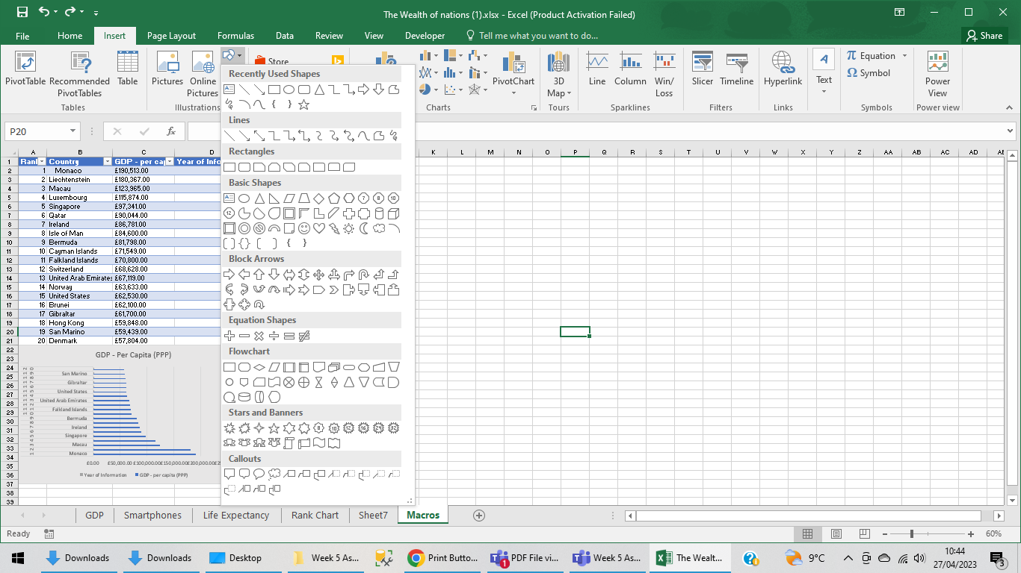

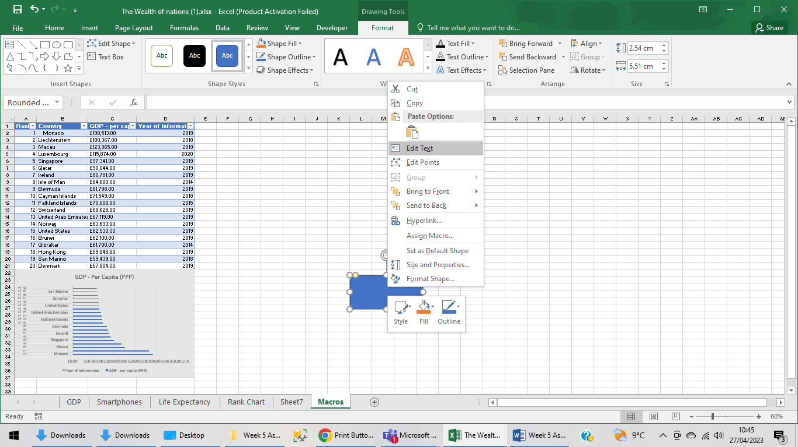

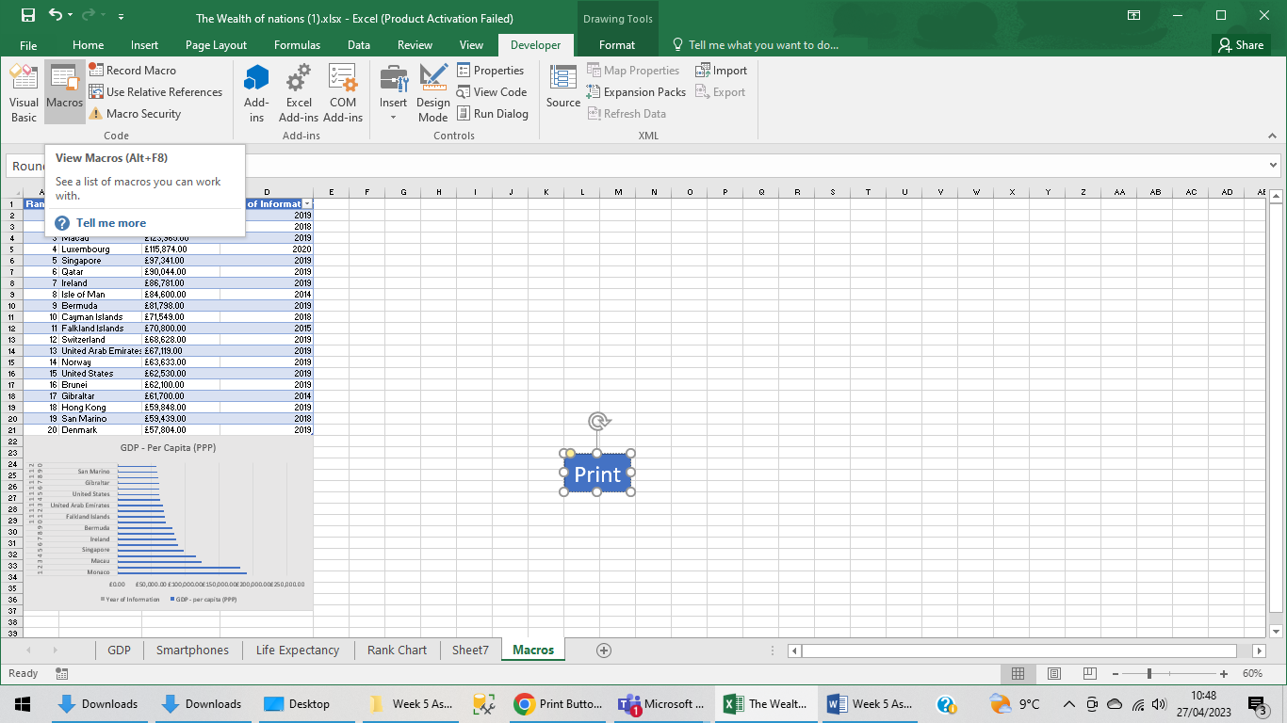

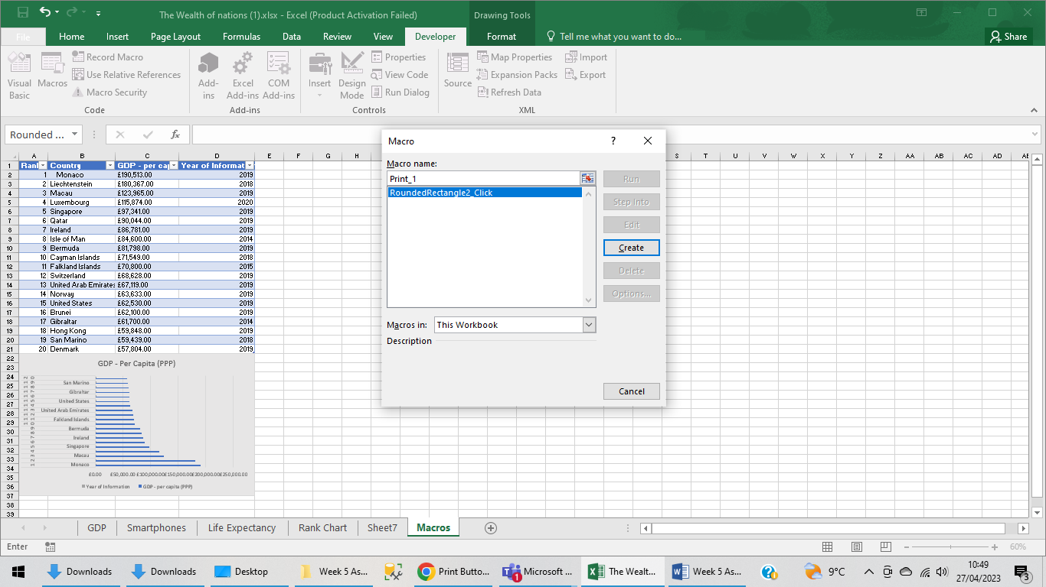

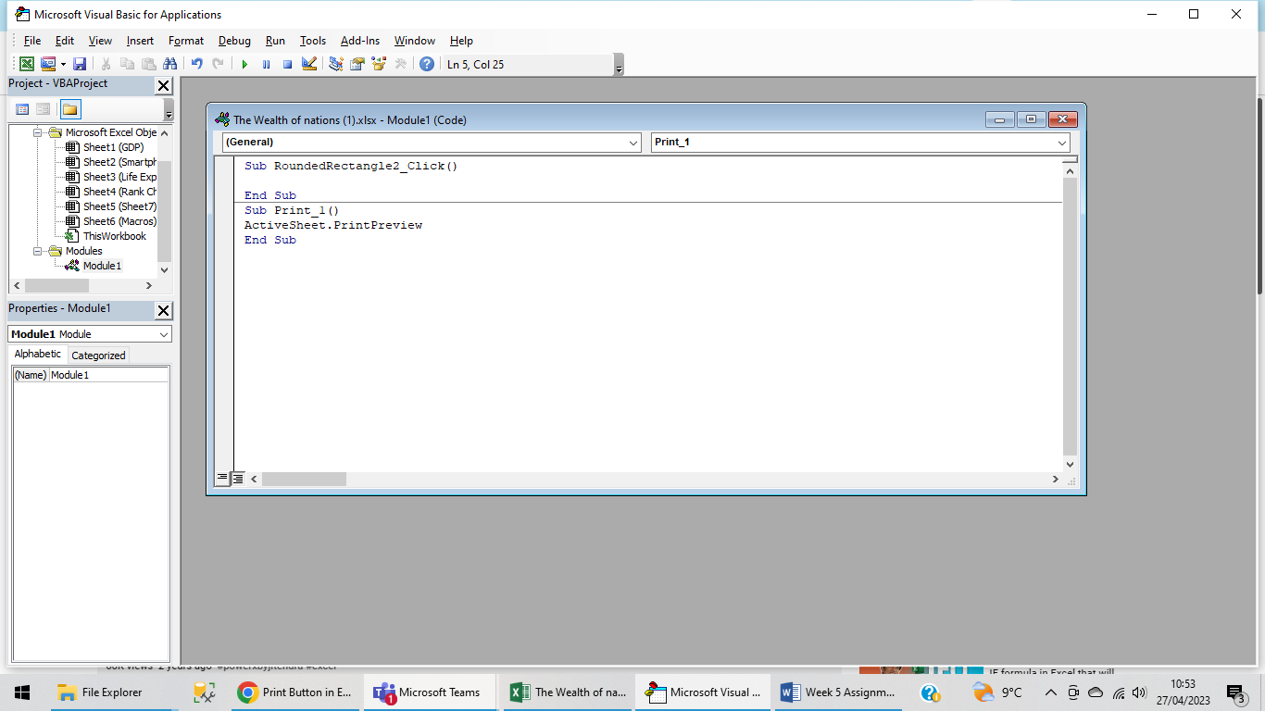

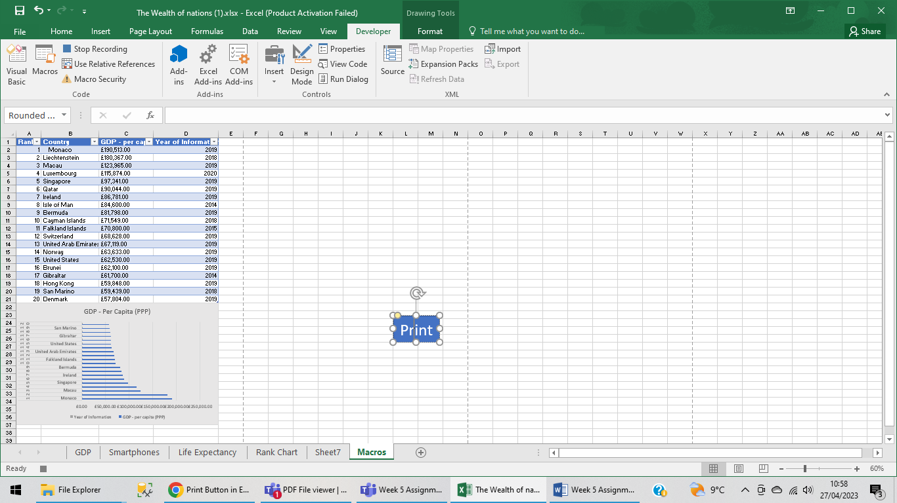

Assigning the print function

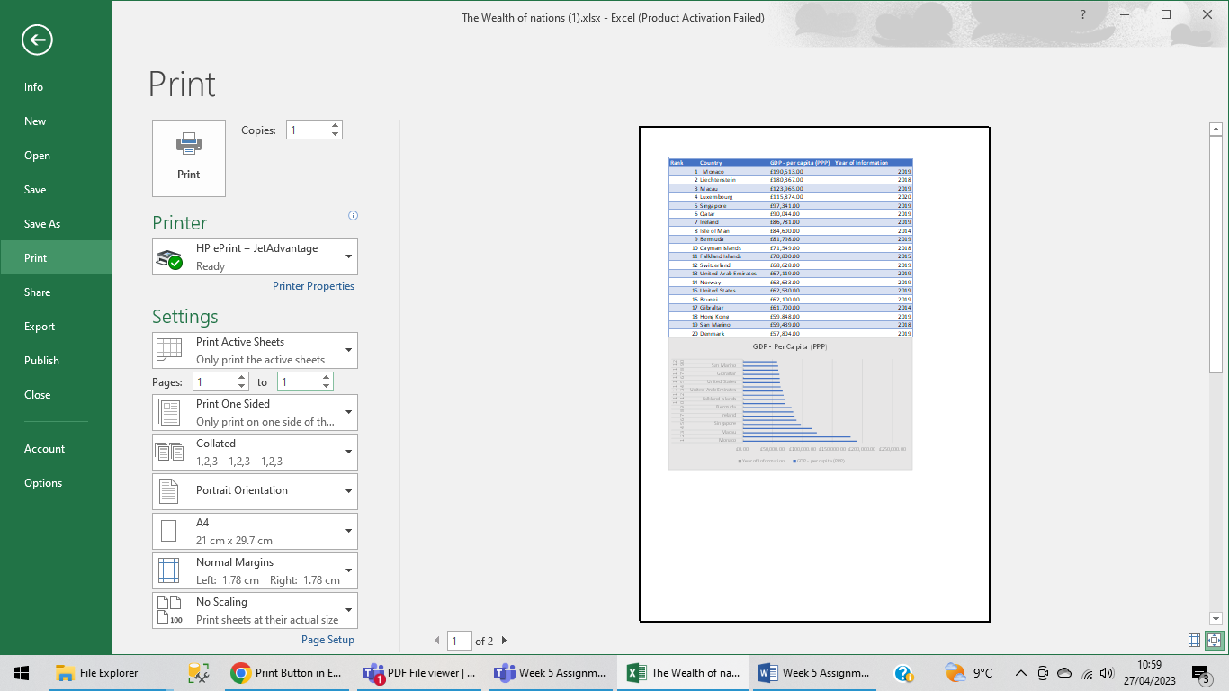

Stop Recording.

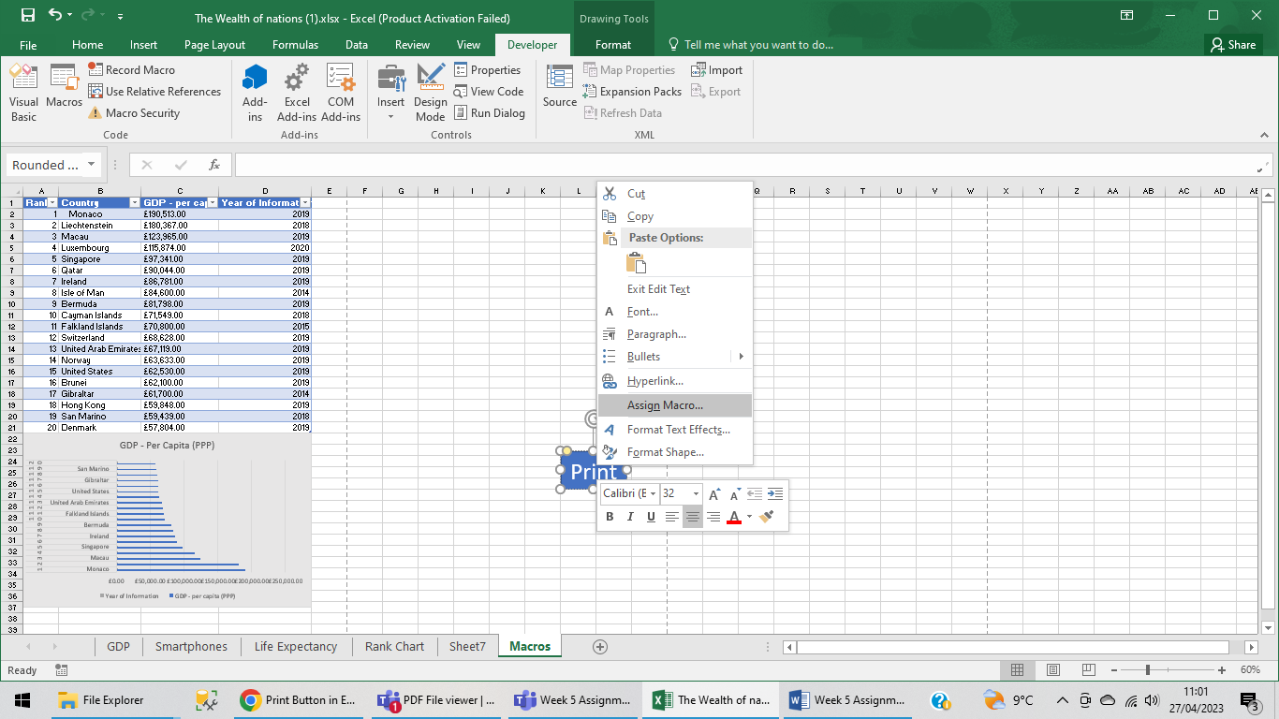

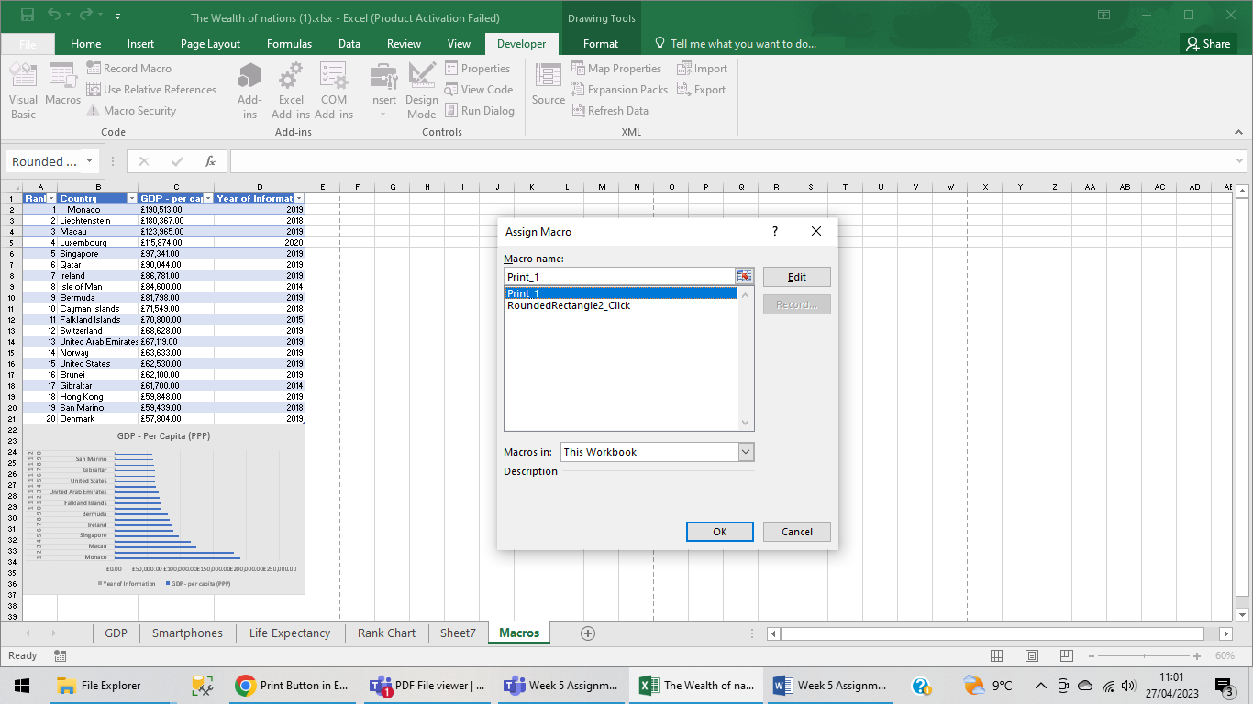

Finishing the Print Macro function.

Copy Macro function.

Same steps for making the button and then start recording Macro and highlight the chart and press CTRL C. stop the Macro.

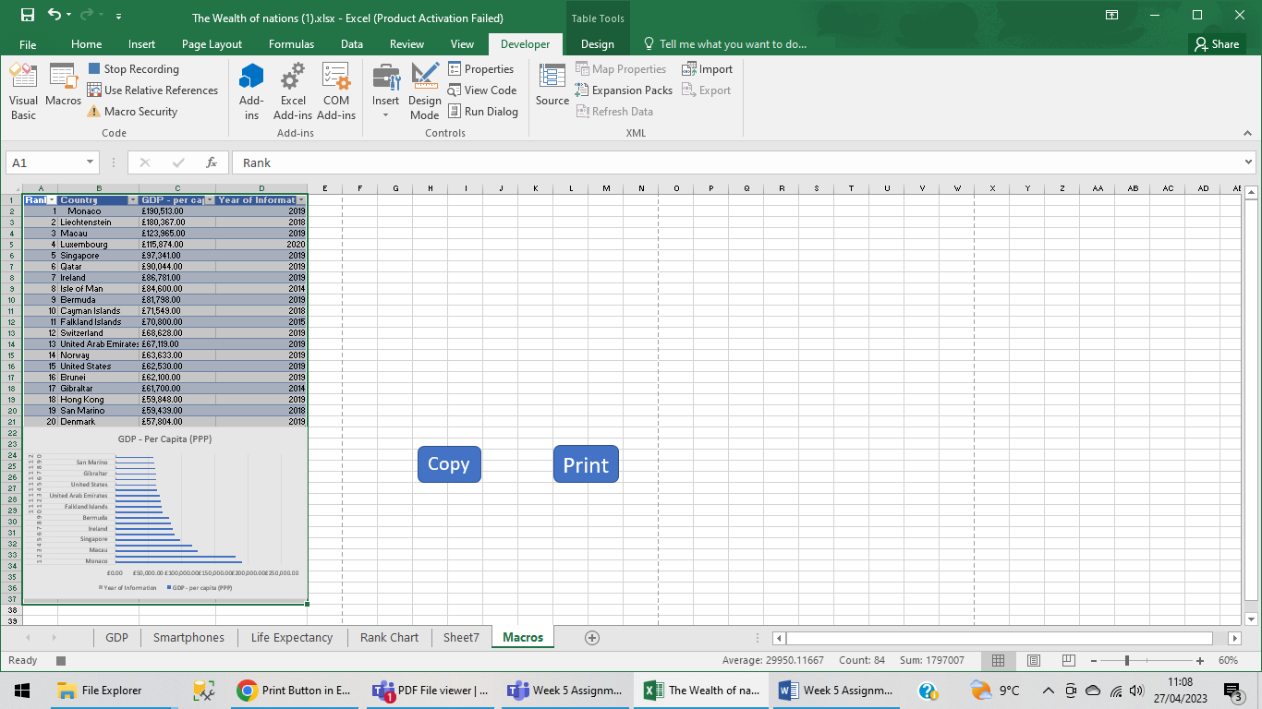

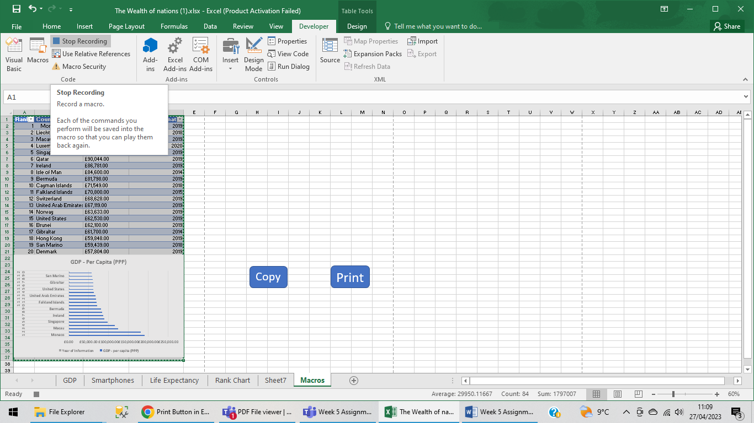

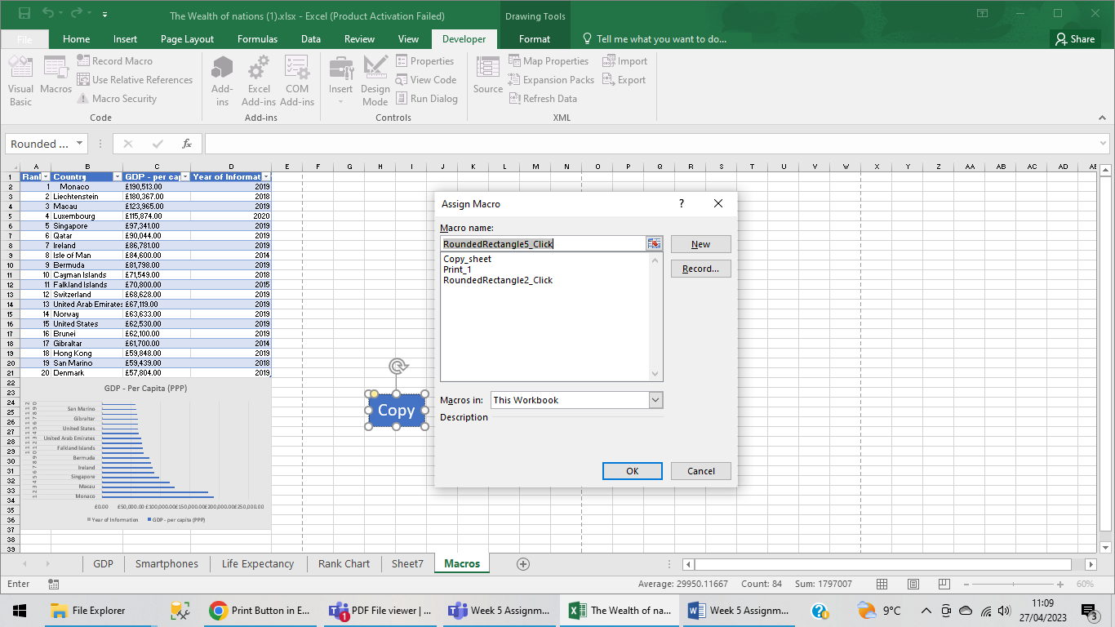

|  |  |  |  |
| --- | --- | --- | --- |
| **Rank** | **Country** | **GDP - per capita (PPP)** | **Year of Information** |
| 1 | Monaco | £190,513.00 | 2019 |
| 2 | Liechtenstein | £180,367.00 | 2018 |
| 3 | Macau | £123,965.00 | 2019 |
| 4 | Luxembourg | £115,874.00 | 2020 |
| 5 | Singapore | £97,341.00 | 2019 |
| 6 | Qatar | £90,044.00 | 2019 |
| 7 | Ireland | £86,781.00 | 2019 |
| 8 | Isle of Man | £84,600.00 | 2014 |
| 9 | Bermuda | £81,798.00 | 2019 |
| 10 | Cayman Islands | £71,549.00 | 2018 |
| 11 | Falkland Islands | £70,800.00 | 2015 |
| 12 | Switzerland | £68,628.00 | 2019 |
| 13 | United Arab Emirates | £67,119.00 | 2019 |
| 14 | Norway | £63,633.00 | 2019 |
| 15 | United States | £62,530.00 | 2019 |
| 16 | Brunei | £62,100.00 | 2019 |
| 17 | Gibraltar | £61,700.00 | 2014 |
| 18 | Hong Kong | £59,848.00 | 2019 |
| 19 | San Marino | £59,439.00 | 2018 |
| |  | | --- | | 20 | | Denmark | £57,804.00 | 2019 |
|  |  |  |  |
|  |  |  |  |
|  |  |  |  |
|  |  |  |  |
|  |  |  |  |
|  |  |  |  |
|  |  |  |  |
|  |  |  |  |
|  |  |  |  |
|  |  |  |  |
|  |  |  |  |
|  |  |  |  |
|  |  |  |  |
|  |  |  |  |
|  |  |  |  |
|  |  |  |  |

Third Task

Data Visualization

Importing Data and Setting relationships

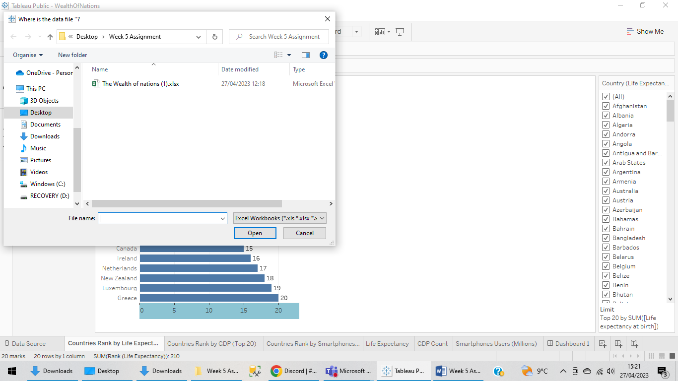

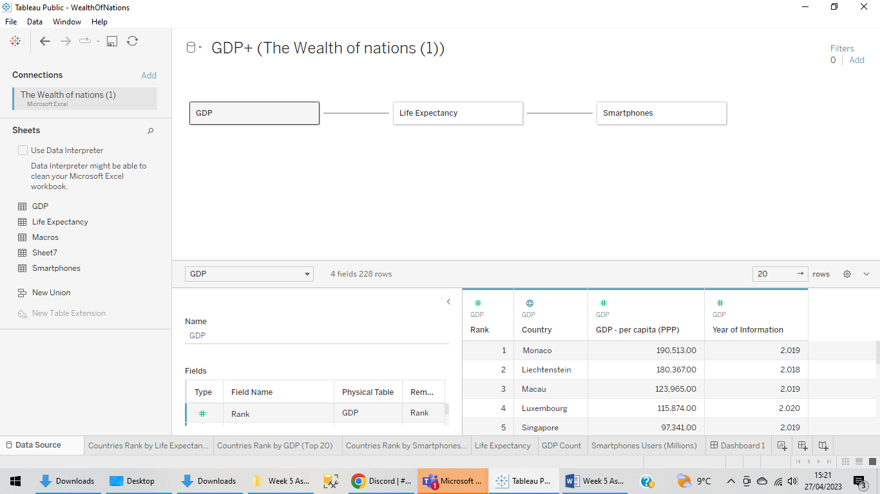

All three Worksheets:

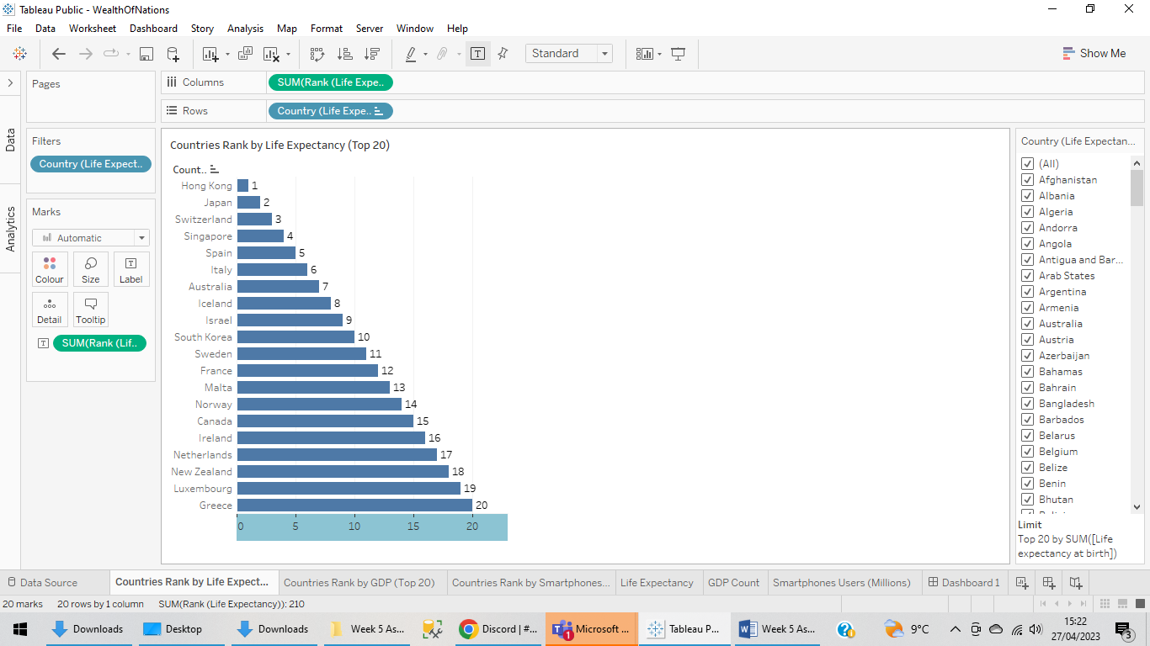

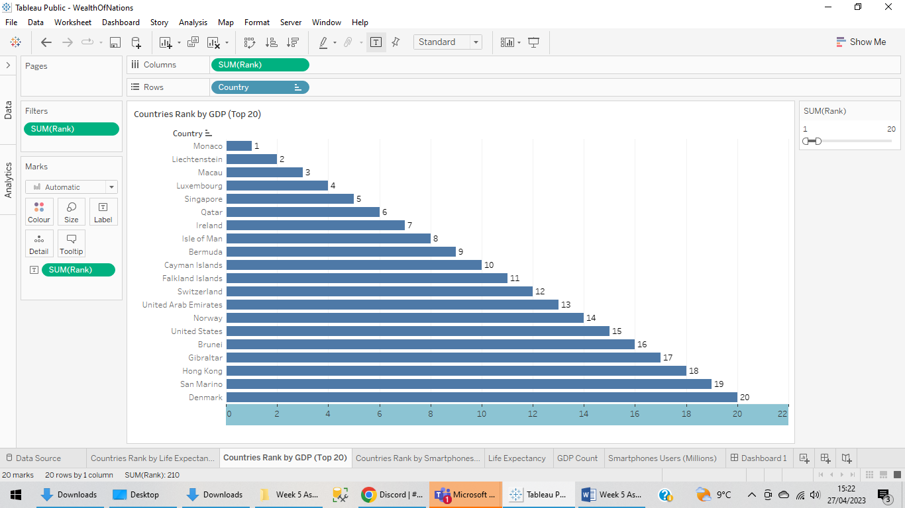

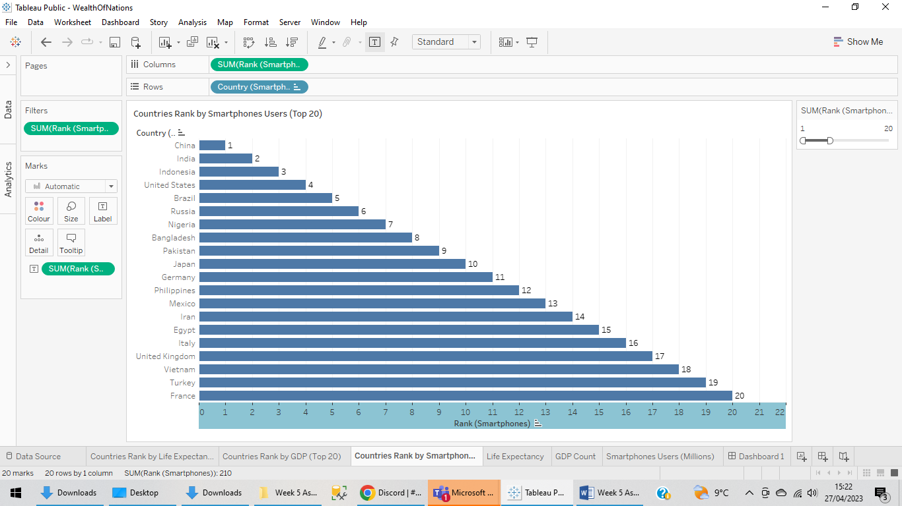

Final Dashboard:

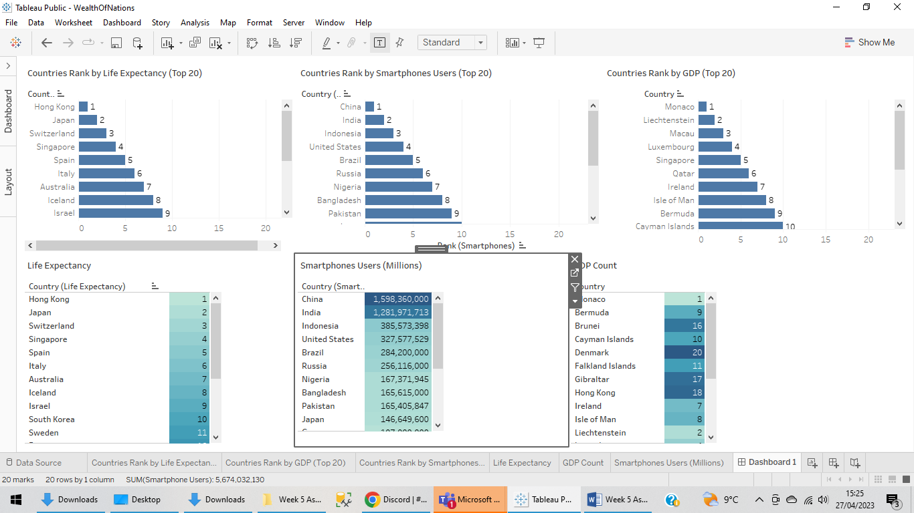

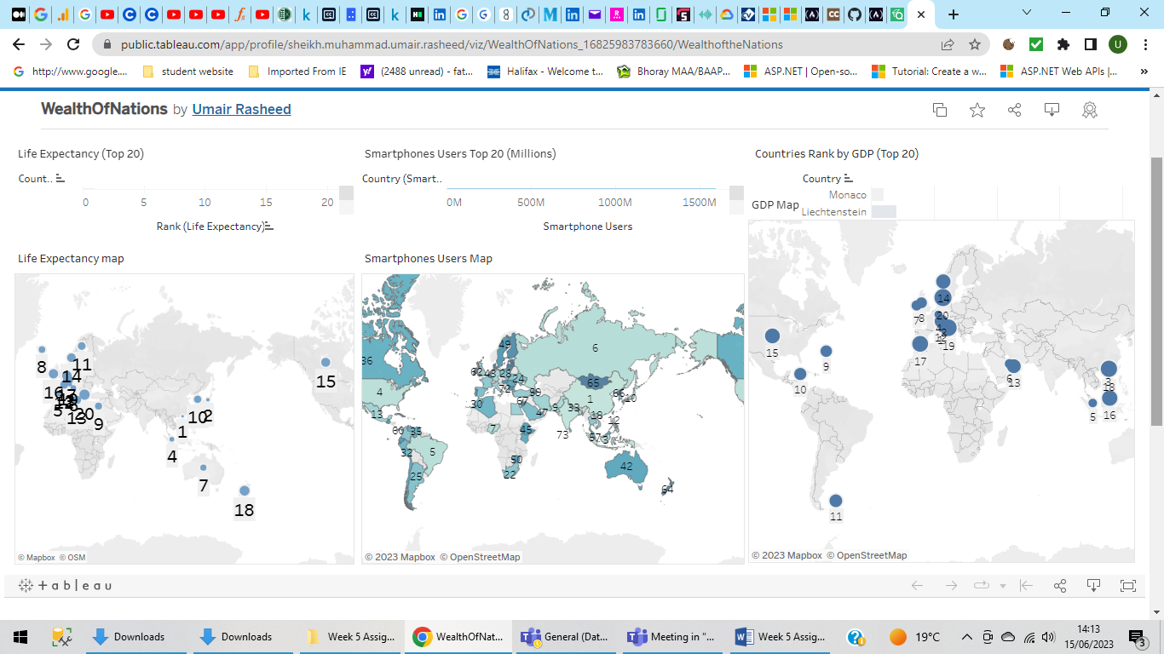

Link to the Tableau Public:

https://public.tableau.com/views/WealthOfNations_16825983783660/WealthoftheNations?:language=en-GB&publish=yes&:display_count=n&:origin=viz_share_link